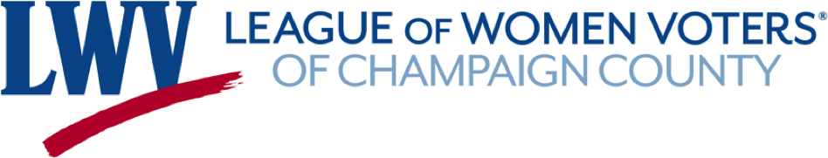

Voter Registration Team Projects
What's in progress for the 2020 election year

Our Focus: We want to increase voter registration and voting by mail for the 2020 election, particularly for:
- Low income/low turnout/underserved groups
- Registered voters—both regular and irregular voters
- Community organizations/networks
- Employees of large employers

Approach to Voter Registration & Education
- Visual, online projects Examples are self-produced videos, social media messages and graphics.
- Collaborate with the Youth Outreach and Civic Education team.
- Take on other community-related projects as they arise and resources are available.

Video Projects
- Two Core Videos - Two core videos, approximately 2-3 minutes each, will cover “How to Register Online” and “How to Register By Mail." These will be fairly general, so they can be used in a variety of situations, such as other videos, sent to community organizations and featured in social media.
Status: The team is talking with a local studio about producing the first core video on registration by the end of June. Outside production help for the second video has not yet been selected. It will be produced later, probably in July, since we must wait on critical vote-by-mail dates to be finalized.

- Theme Video: Vote Safely From Home - This video will speak to anyone who doesn't want to leave their homes to vote, perhaps due to concerns about the coronavirus, but perhaps for other reasons as well. The message is that you can register online at home and vote by mail (the two core videos). Anyone who does both of these is social distance voting. This video will link to the online registration and vote-by-mail videos.

Status: The team is seeking outside production help for this video. We're also doing work on the content and scripts for the videos.

Cartoon Project: Wonder Voter
- The “Wonder Voter” cartoon is a 4-panel cartoon featuring a nervous voter and a cartoon hero who answers voter registration question.
- We have content but need someone with cartooning skills to make it happen.
- The team brainstormed a future idea for a “League of Wonder Voters” (LWV!) series.
Status: One of our team members has a nephew who’s going to draft the first cartoon, but we are keeping our eyes open for other cartoonists who may want to help in the future.

Election Messages Project
- Create a set of graphics/messages that can be used for the run-up to November 3. Examples might be a simple "Go Vote" images or a graphic with key election dates and reminders.
- Send these graphics/message out from June/July to Election Day on November 3.

Status: We have drafted an initial set of messages, a rough calendar and a high-level publicity plan. Currently we are researching and deciding on the exact messages and their format. Upcoming work is to create and review message and develop more detailed calendar and publicity plans. We will also need more team members to help with the next steps and to implement the plan.

